Group 1 – Task 3.1

Team members:

Brayden Di Luca (braydend) 100590789  
Chris Fulgueras (chrisflgs) 9731417  
Kyle Zaccagnini (XtremeCatalystXD) 101096251 - Me

In the wiki I set up the following pages:

**Team and Title Details**

**Game screens and flow**

**User Interface**

The images of the boards were derived from an externally sourced image. The image was then modified and altered to show various stages of the game.

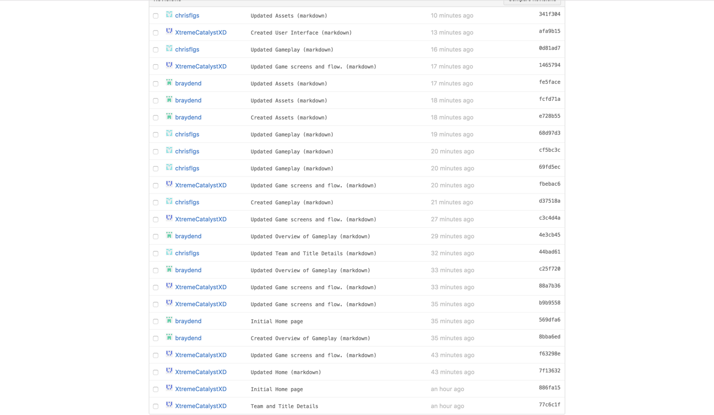

The wiki can be found here: <https://github.com/braydend/Battleships/wiki/>